VALIDATION PROTOCOL & REPORT
The Government Pharmaceutical Organization
Rangsit Pharmaceutical Production Plant
138, Rangsit–Nakhonnayok Road Thanyaburi, Pathumthani, Thailand
Document number: VP-AMB6-C-001 Rev. 01
VALIDATION OF ADVANCE FAILURE MONITORING SYSTEM
Facility: Warehouse and logistics maintenance section
Completion of the below signatures indicates that the responsible parties have reviewed the validation documents, including the protocols and results, and verify that all validation activities have been approved and completed. The checklists of the reviewed and approved items for all specification and testing immediately follow this approval page.

Prepared by Date
(……………………………………..………………..…………….)
Pharmacist 5, Equipment Qualification Section

Date
(……………………………………..………………..…………….)
Head of Warehouse and logistics maintenance section

Reviewed by Date
(……………………………………..………………..…………….)
Head of Equipment Qualification Section

Date
(……………………………………..………………..…………….)
Director of Rangsit Manufacturing Machinery Maintenance Engineering Division

Approved by Date
(……………………………………..………………..…………….)
Director of Validation of Manufacturing System Division

Revision History
Note: The issuance, revision, and withdrawal of all documents should be controlled and archived for at least for 3 consecutive revisions. Documents changed from GMP impact must be controlled and archived every revision.
Rev. No. | Eff. Date | Summary of Change | Editor
01 | 22/12/2025 | The first issuance of document. | Janyaporn K.,  Pharmacist 5, Equipment Qualification Section

OBJECTIVE
- To verify that the Advanced Failure Monitoring System performs correctly and reliably perform its intended functionality.
- To demonstrate that the Advanced Failure Monitoring System meets all applicable regulatory and User Requirements Specifications (URS).
- To demonstrate that the protocols and results have been documented, and approved that all validation activities have been completed.

SCOPE
This validation covers the configuration & Functional testing of all functions with GxP impact in the Advanced Failure Monitoring System used in the Warehouse and Logistics Maintenance Section, The key validation activities and procedures based on Computerized System Validation Master Plan and ISPE GAMP® 5 second edition.

SYSTEM DESCRIPTION
The advanced Failure Monitoring System was developed to enhance notifications for temperature control systems within distribution centers, cold storage, and refrigeration units. It ensures high-precision, continuous monitoring and delivers efficient, real-time alerts regardless of time or location.

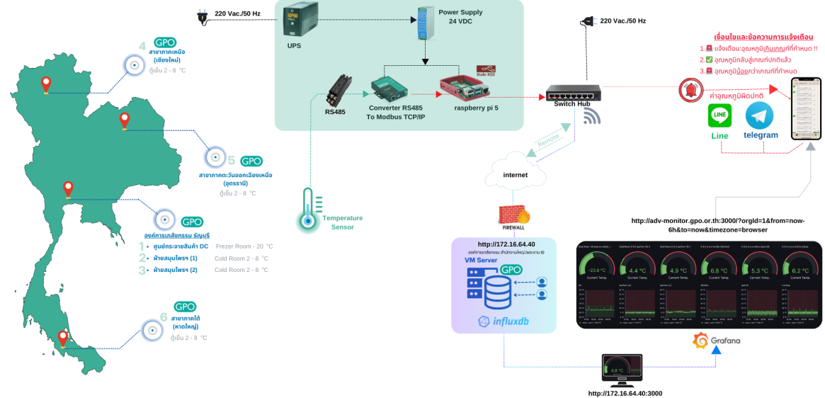
The system's operation commences with the Temperature Sensor capturing environmental data. The RS485 interface then digitizes these readings into the Modbus RTU protocol. Subsequently, a Converter performs protocol translation, converting Modbus RTU to Modbus TCP. Subsequently, the Raspberry Pi receives and processes the data according to the programmed instructions. In the event of any detected anomalies, the system triggers automated alerts via LINE and TELEGRAM. Furthermore, the data is transmitted to a central server for visualization on a Grafana dashboard, enabling real-time temperature monitoring.

An evaluation was performed in accordance with GAMP® 5 principles, and the following results were obtained:
Category | Description
Software category 5 | Custom products – products that are developed to meet the specific requirements and using for specific purpose.
Hardware category 1 | Standard Hardware
Operating system: Linux 6.12.25+rpt-rpi-2712 arm64 LE (Category 1)

For Software Category 5, using the workflow functionalities have been developed. Therefore unit testing/integration testing, functional testing and requirements testing are required in accordance with GAMP ® 5 guidelines.
Regarding the validation activities, these shall be identified based on the validation lifecycle.
The activities can be broadly divided into four steps:
- Planning
- Specification, Configuration, and Coding
- Verification
- Reporting and Release
System risks were evaluated based on their direct and indirect GxP impact, with risk levels categorized in accordance with QP-AK20-007: GxP Computerised System Risk Assessment. The results are summarized in the table below:
 | Number of Business Processes
GxP Impact and Criticality Assessment |  | Total Number
Direct Impact & Critical | 8 | 10
Direct Impact & Non Critical | 0 | 10
Indirect Impact | 2 | 10
No Impact | 0 | 10
FUNCTIONAL RISK ASSESSMENT (FRA)  (FRA is assessed only for Direct Impact & Critical Processes) |  | Total Number
High risk | 6 | 10
Medium risk | 2 | 10
Low risk | 2 | 10

Qualification Document Review Checklist (1/2)
No. | Qualification Activities | Appendix No. | Requirements | Satisfactory  (Y, N, N/A) | Remark
1 | Requirement Specification |  | Document is available in a reviewed and approved form. | Y
2 | Module (Unit), Design and Configuration/ Functional Specification |  | Document is available in a reviewed and approved form. | Y
3 | Hardware Acceptance Test |  | Document is available in a reviewed and approved form. | Y
3 | Hardware Acceptance Test |  | All tests included in protocol have been successfully performed. | Y
4 | Module (Unit) Testing |  | Document is available in a reviewed and approved form. | Y
4 | Module (Unit) Testing |  | All tests included in protocol have been successfully performed. | Y
5 | Integration Testing |  | Document is available in a reviewed and approved form. | Y
5 | Integration Testing |  | All tests included in protocol have been successfully performed. | Y
5 | Integration Testing |  | The system complies with the design specification. | Y
6 | Configuration/  Functional Testing |  | Document is available in a reviewed and approved form. | Y
6 | Configuration/  Functional Testing |  | All tests included in protocol have been successfully performed. | Y
6 | Configuration/  Functional Testing |  | All the deviation(s) has been closed and recorded in a reviewed and approved form. | N
6 | Configuration/  Functional Testing |  | The system complies with the configuration/functional specification. | Y
7 | Requirements Testing |  | Document is available in a reviewed and approved form. | Y
7 | Requirements Testing |  | All tests included in protocol have been successfully performed. | Y
7 | Requirements Testing |  | All the deviation(s) has been closed and recorded in a reviewed and approved form. | N
7 | Requirements Testing |  | The system complies with the user requirement specification. | Y
Checked By ___________________________________________ Date ________________________
Reviewed By ___________________________________________Date ________________________
Qualification Document Review Checklist (2/2)
Remarks:
Conclusion
□ Passed. All validation activities of the system are found to be successfully completed and the results have been reviewed to be acceptable.
□ Conditional passed as there are ____ deviation(s). ^{[a]}
□ Fail. Deviation no.______
^{[a]} These deviations are assessed to have no impact on safety and product quality. The deviations will be followed up / re-test.

Checked By __________________________________________ Date ________________________
Reviewed By _________________________________________ Date ________________________

List of Appended Document
No. | Documents No. | Document name | No. of Pages
1
2
3
4

Checked By __________________________________________ Date ________________________

Reviewed By _________________________________________ Date ________________________

PROTOCOL APPROVAL PAGE

Prepared by Date
(……………………………………..………………..…………….)
Pharmacist 5, Equipment Qualification Section

Date
(……………………………………..………………..…………….)
Head of Warehouse and logistics maintenance section

Reviewed by Date
(……………………………………..………………..…………….)
Head of Equipment Qualification Section

Date
(……………………………………..………………..…………….)
Director of Rangsit Manufacturing Machinery Maintenance Engineering Division

Approved by Date
(……………………………………..………………..…………….)
Director of Validation of Manufacturing System Division

POST-EXECUTION REPORT APPROVAL

Prepared by Date
(……………………………………..………………..…………….)
Pharmacist 5, Equipment Qualification Section

Date
(……………………………………..………………..…………….)
Head of Warehouse and logistics maintenance section

Reviewed by Date
(……………………………………..………………..…………….)
Head of Equipment Qualification Section

Date
(……………………………………..………………..…………….)
Director of Rangsit Manufacturing Machinery Maintenance Engineering Division

Approved by Date
(……………………………………..………………..…………….)
Director of Validation of Manufacturing System Division

APPROVAL REPORT AFTER FOLLW UP

Prepared by Date
(……………………………………..………………..…………….)
Pharmacist 5, Equipment Qualification Section

Date
(……………………………………..………………..…………….)
Head of Warehouse and logistics maintenance section

Reviewed by Date
(……………………………………..………………..…………….)
Head of Equipment Qualification Section

Date
(……………………………………..………………..…………….)
Director of Rangsit Manufacturing Machinery Maintenance Engineering Division

Approved by Date
(……………………………………..………………..…………….)
Director of Validation of Manufacturing System Division

